

|  |  |  |  |  |  |  |  |  |  |  |  |
| --- | --- | --- | --- | --- | --- | --- | --- | --- | --- | --- | --- |
| **Benodigdhede vir hierdie vraestel/Requirements for this paper:** | | | | | |  |  |  |  |  |  |
|  | **Multikeusekaarte/**  **Multi-choice cards:** |  |  | **Nie-programmeerbare sakrekenaar/**  **Non-programmable calculator:** |  |  |  |  | **Oopboek-eksamen/**  **Open book examination?** | **NEE/**  **NO** |  |
|  |  |  |  |  |  |  |  |  |  |  |  |
|  | **Grafiekpapier/**  **Graph paper:** |  |  | **Draagbare Rekenaar/**  **Laptop:** |  |  |  |  |  |  |  |
|  |  |  |  |  |  |  |  |  |  |  |  |

|  |  |  |  |  |
| --- | --- | --- | --- | --- |
| **EKSAMEN/TOETS**  **EXAMINATION/TEST:** | **Semester Test 1** | **KWALIFIKASIE/**  **QUALIFICATION:** | **B.Sc / B.Com /BA** | |
| **MODULEKODE/**  **MODULE CODE:** | **ITRW321** | | **TYDSDUUR/**  **DURATION:** | **1½ uur/hour** |
| **MODULEBESKRYWING/**  **MODULE DESCRIPTION:** | **Databasis II / Databasisse II** | | **MAKS/**  **MAX:** | **75** |
| **EKSAMINATOR(E)/**  **EXAMINER(S):** | **AR BOTES** | | **DATUM/**  **DATE:** | **15/08/2013** |
|  | **PROF PD JORDAAN** | | **TYD/TIME:** | **8:00** |
| **MODERATOR:** |  | |  |  |

Start type the Examination Paper on the next Paragraph

***QUESTION 1***

1. **True/False**
   * 1. Distributed database systems do not require complex mechanisms to manage transactions and ensure the database's consistency and integrity.
     2. The DBA is responsible for ensuring that the data are distributed to the right persons, at the right time, and in the right format.
     3. The maintenance activities of the DBA are an extension of the operational activities.
   1. **Multiple Choice**
      1. ____ transparency allows a transaction to update data at several network sites.

a. Transaction c. Failure

b. Distribution d. Performance

* + 1. ____ is the delay imposed by the amount of time required for a data packet to make a round trip from point A to point B.

a. Data distribution c. Network latency

b. Replica transparency d. Network partitioning

* + 1. The ____ administrator is responsible for strategic planning.

a. system c. database

b. data d. program

* + 1. ____ management is designed to limit access to the database.

a. Authorization c. View

b. User access d. DBMS utility

* 1. **Completion**

Complete each statement.

* + 1. ODBC is ____________________’s implementation of a superset of the SQL Access Group CLI.
    2. The Microsoft ____________________ framework is a component-based platform for developing distributed, heterogeneous, interoperable applications aimed at manipulating any type of data over any network under any operating system and any programming language.
    3. The requirement that a password must have a maximum of 12 characters is an example of a(n) ____________________.
    4. Explain the need for the two-phase commit protocol. Then describe the two phases. (8)

**The two-phase commit protocol guarantees that if a portion of a transaction operation cannot be committed; all changes made at the other sites participating in the transaction will be undone to maintain a consistent database state.**

**In a DDBMS, an algorithm used to ensure atomicity of transactions and database consistency as well as integrity in distributed transactions.**

**Phase 1: Preparation**

**The coordinator sends a PREPARE TO COMMIT message to all subordinates.**

**1. The subordinates receive the message; write the transaction log, using the write-ahead protocol; and send an acknowledgment (YES/PREPARED TO COMMIT or NO/NOT PREPARED) message to the coordinator.**

**2. The coordinator makes sure that all nodes are ready to commit, or it aborts the action.**

**If all nodes are PREPARED TO COMMIT, the transaction goes to Phase 2. If one or more nodes reply NO or NOT PREPARED, the coordinator broadcasts an ABORT message to all subordinates.**

**Phase 2: The Final COMMIT**

**1. The coordinator broadcasts a COMMIT message to all subordinates and waits for the replies.**

**2. Each subordinate receives the COMMIT message, and then updates the database using the DO protocol.**

* + 1. What is a DataSet, and why is it considered to be disconnected? (6)

**A DataSet is a disconnected memory-resident representation of the database. That is, the DataSet contains tables, columns, rows, relationships, and constraints. Once the data are read from a data provider, the data are placed on a memory-resident DataSet. The DataSet is then disconnected from the data provider. The data consumer application interacts with the data in the DataSet object to make changes (inserts, updates and deletes) in the dataset. Once the processing is done, the DataSet data are synchronized with the data source and the changes are made permanent.**

**A DataSet is in fact a simple database with tables, rows and constraints. Even, more important, the DataSet doesn’t require keeping a permanent connection to the data source. The DataAdapter uses the SelectCommand to populate the DataSet from a data source. However, once the DataSet is populated, it is completely independent of the data source – that’s why it’s called “disconnected.”**

* + 1. Explain the difference between distributed databases and client/server architecture. (5)

**Client/server architecture refers to the way in which computers interact to form a system. The client/server architecture features a *user* of resources, or a client, and a *provider* of resources, or a server. The client/server architecture can be used to implement a DBMS in which the client is the TP and the server is the DP.**

**Client/server interactions in a DDBMS are carefully scripted. The client (TP) interacts with the end user and sends a request to the server (DP). The server receives, schedules, and executes the request, *selecting only those records that are needed by the client*. The server then sends the data to the client *only* when the client requests the data.**

**[19]**

***QUESTION 2***

1. Use a diagram to illustrate web-to-database middleware (15)

**[15]**

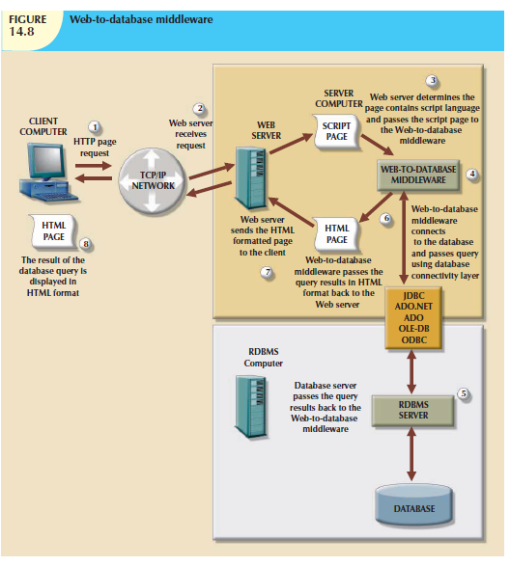

***QUESTION 3***

1. The following data structure and constraints exist for a magazine publishing company:

a. The company publishes one regional magazine in each region: Florida (FL), South Carolina (SC), Georgia (GA), and Tennessee (TN).

b. The company has 300,000 customers (subscribers) distributed throughout the four states listed in Part a.

c. On the first of each month, an annual subscription INVOICE is printed and sent to each customer whose subscription is due for renewal. The INVOICE entity contains a REGION attribute to indicate the state (FL, SC, GA, TN) in which the customer resides:

CUSTOMER (CUS_NUM, CUS_NAME, CUS_ADDRESS, CUS_CITY, CUS_ZIP, CUS_SUBSDATE)

INVOICE (INV_NUM, INV_REGION, CUS_NUM, INV_DATE, INV_TOTAL)

The company’s management is aware of the problems associated with centralized management and has decided to decentralize management of the subscriptions into the company’s four regional subsidiaries. Each subscription site will handle its own customer and invoice data. The management at company headquarters, however, will have access to customer and invoice data to generate annual reports and to issue ad hoc queries such as:

- List all current customers by region.

- List all new customers by region.

- Report all invoices by customer and by region.

* 1. What recommendations will you make regarding the type and characteristics of the required database system? (5)

**The Magazine Publishing Company requires a distributed system with distributed database capabilities. The distributed system will be distributed among the company locations in France (FR), Italy (IT), The Netherlands (NL), and United Kingdom (UK).**

**The DDBMS must be able to support distributed transparency features, such as fragmentation transparency, replica transparency, transaction transparency, and performance transparency. Heterogeneous capability is not a mandatory feature since we assume.**

* 1. What type of data fragmentation is needed for each table? (3)

**The database must be horizontally partitioned, using the CUST_REGION attribute for the**

**CUSTOMER table and the REGION attribute for the INVOICE table.**

* 1. What criteria must be used to partition each database? (10)

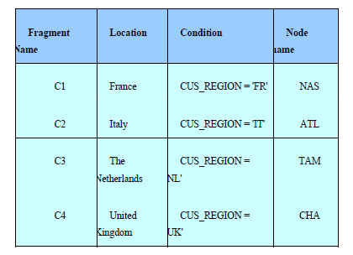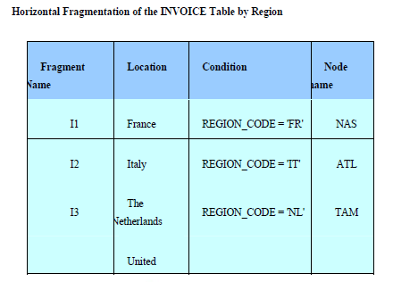

**[28]**

***QUESTION 4***

* 1. Define security and privacy. How are these two concepts related? (8)

**Security means protecting the data against accidental or intentional use by unauthorized users. Privacy deals with the rights of people and organizations to determine who accesses the data and when, where, and how the data are to be used.**

**The two concepts are closely related. In a shared system, individual users must ensure that the data are protected from unauthorized use by other individuals. Also, the individual user must have the right to determine who, when, where, and how other users use the data. The DBMS must provide the tools to allow such flexible management of the data security and access rights in a company database.**

* 1. In Oracle, what is a database schema? (5)

**A database schema is a logical section of the database that belongs to a given user. Each schema is identified by the username. For example, if a user named SYSTEM creates a CHARTER table, that table will belong to the SYSTEM schema. Oracle uses the username (= schema name) as a prefix to the table name. Therefore, the example's CHARTER table will be identified as SYSTEM.CHARTER by Oracle.**

**[13]**

TOTAL: 75